1.Launch the below URL's in firefox browser:

-------------------------------------------

1.Greens technologys - <http://www.greenstechnologys.com/>

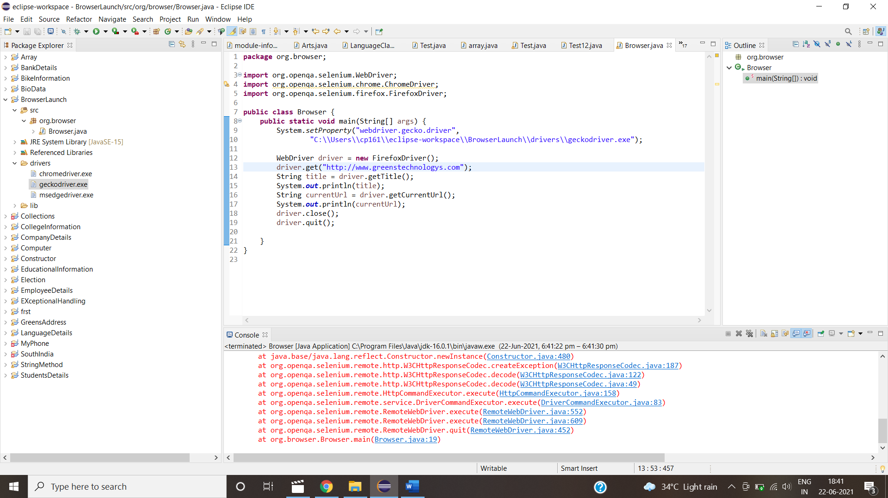

2.Facebook - <https://www.facebook.com/>

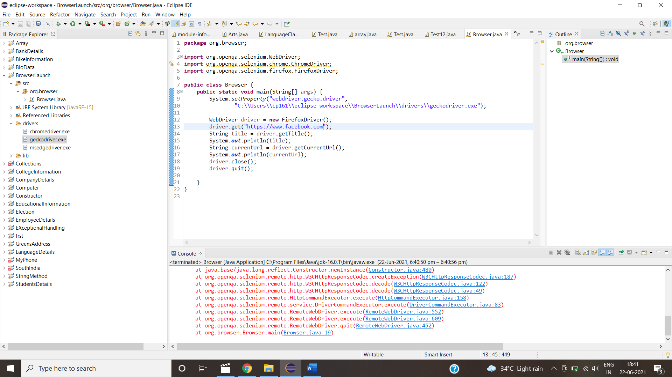

3.Amazon - <https://www.amazon.in>

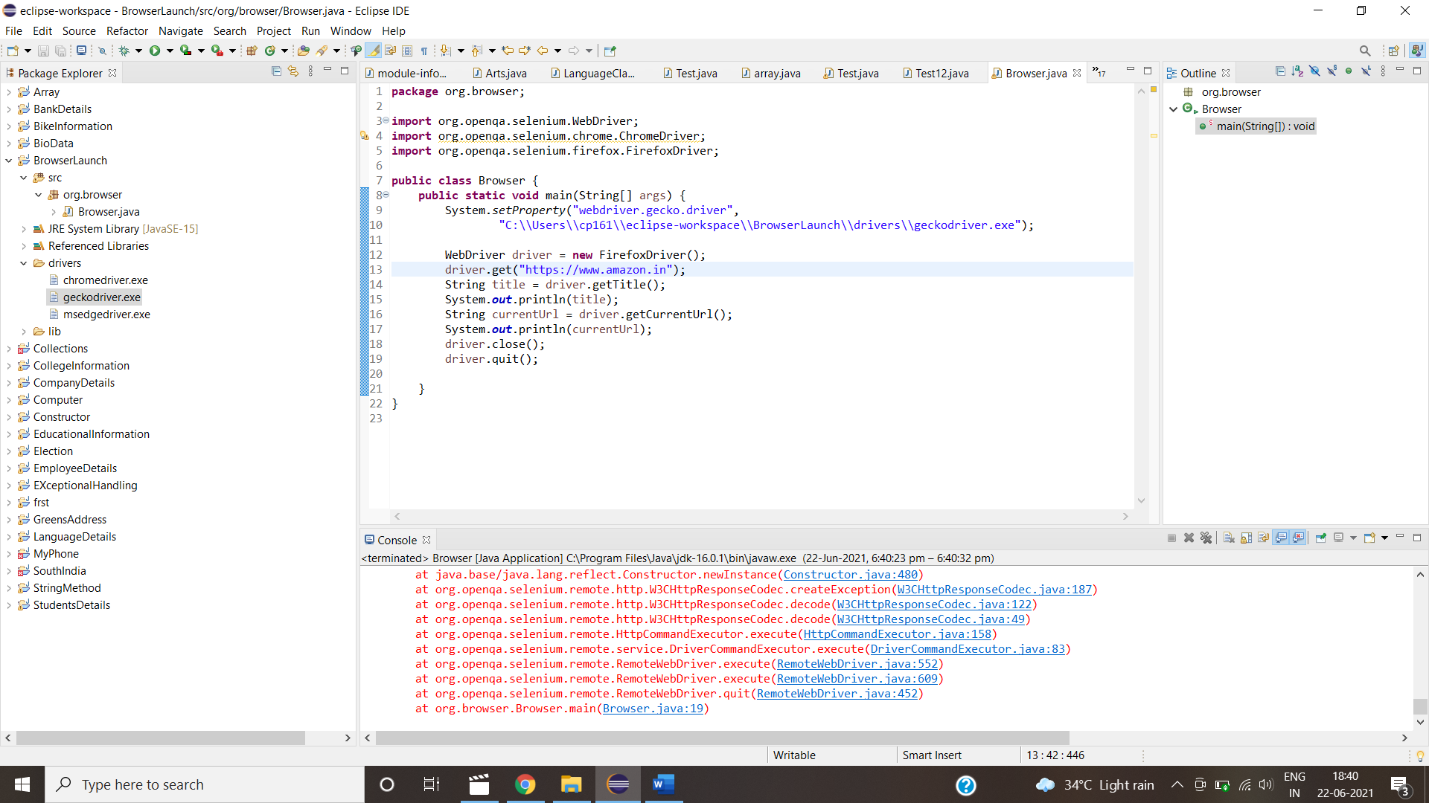

4.Greens technologys-http://greenstech.in/selenium-course-content.html

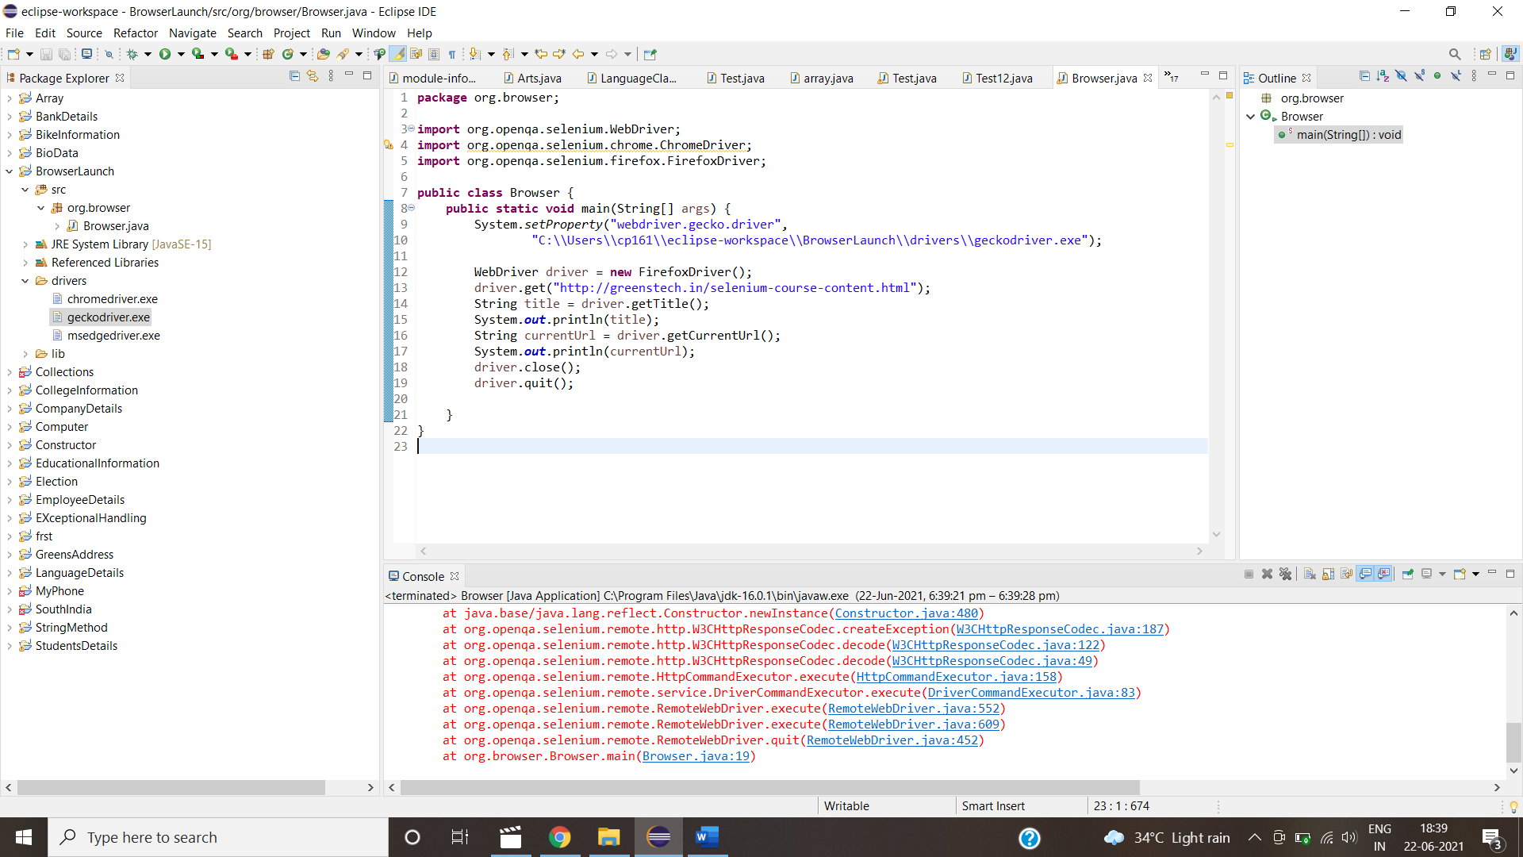

2.Launch the below URL's in chrome browser:

------------------------------------------

1.Greens technologys - <http://www.greenstechnologys.com/>

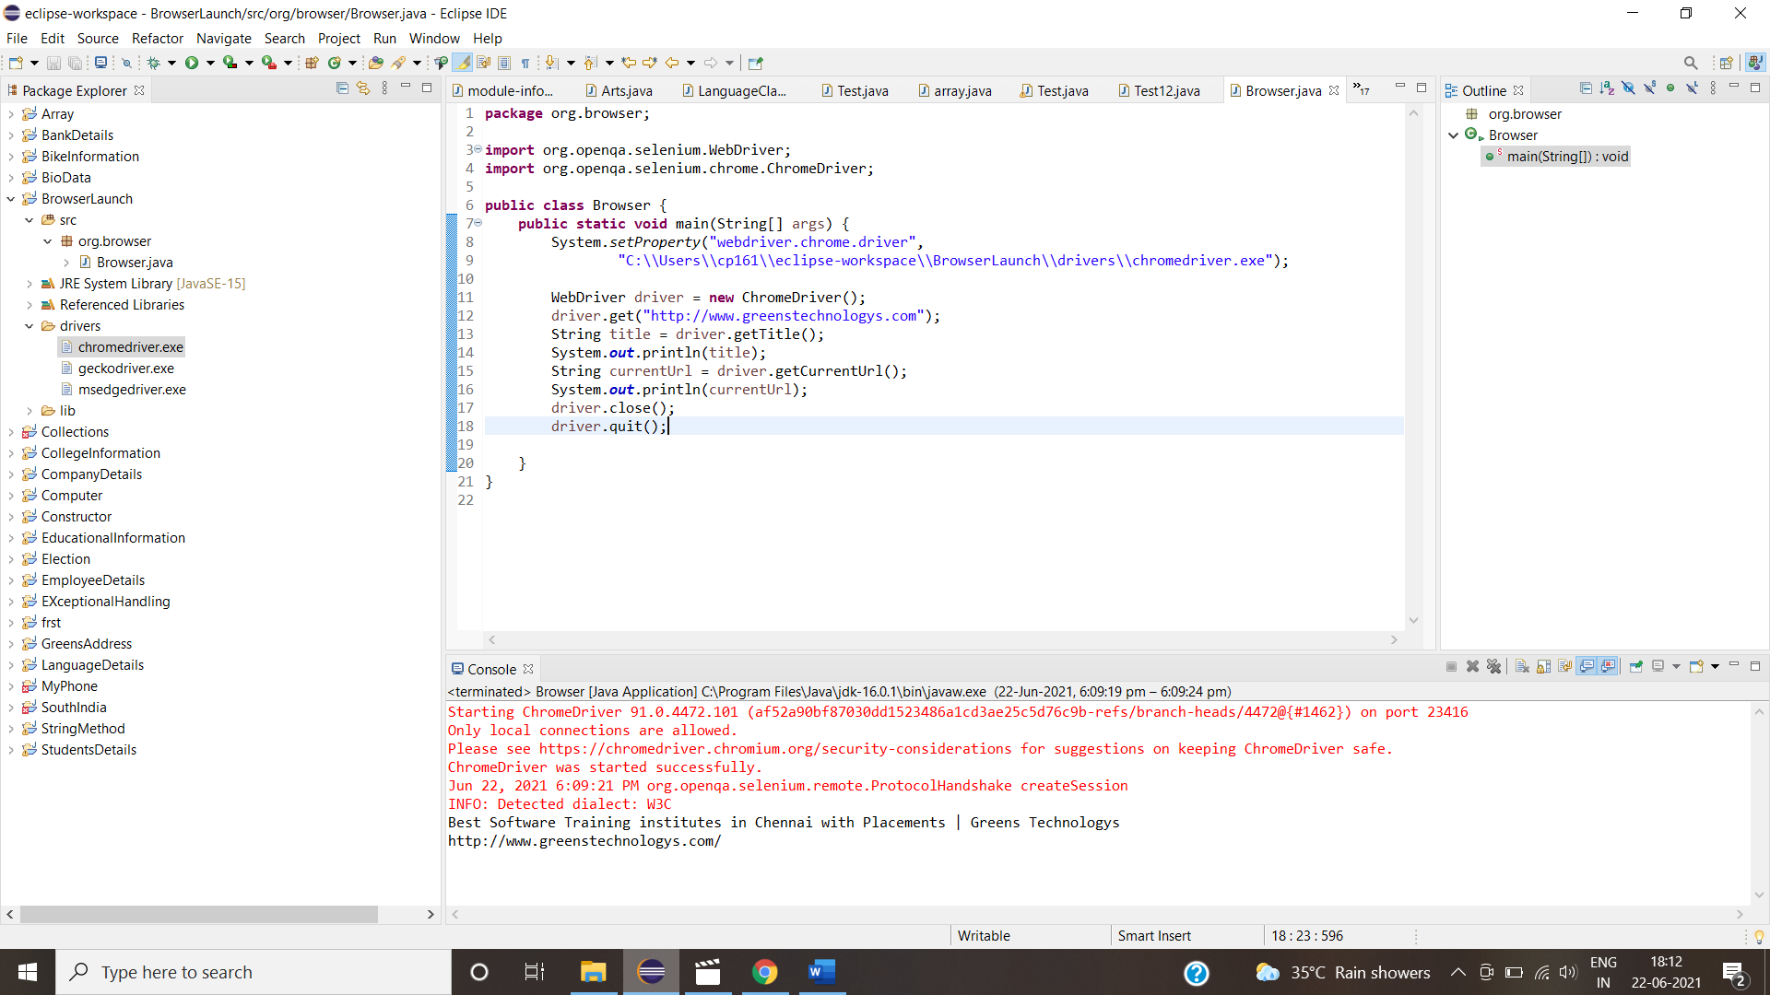

2.Gmail - <http://gmail.com/>

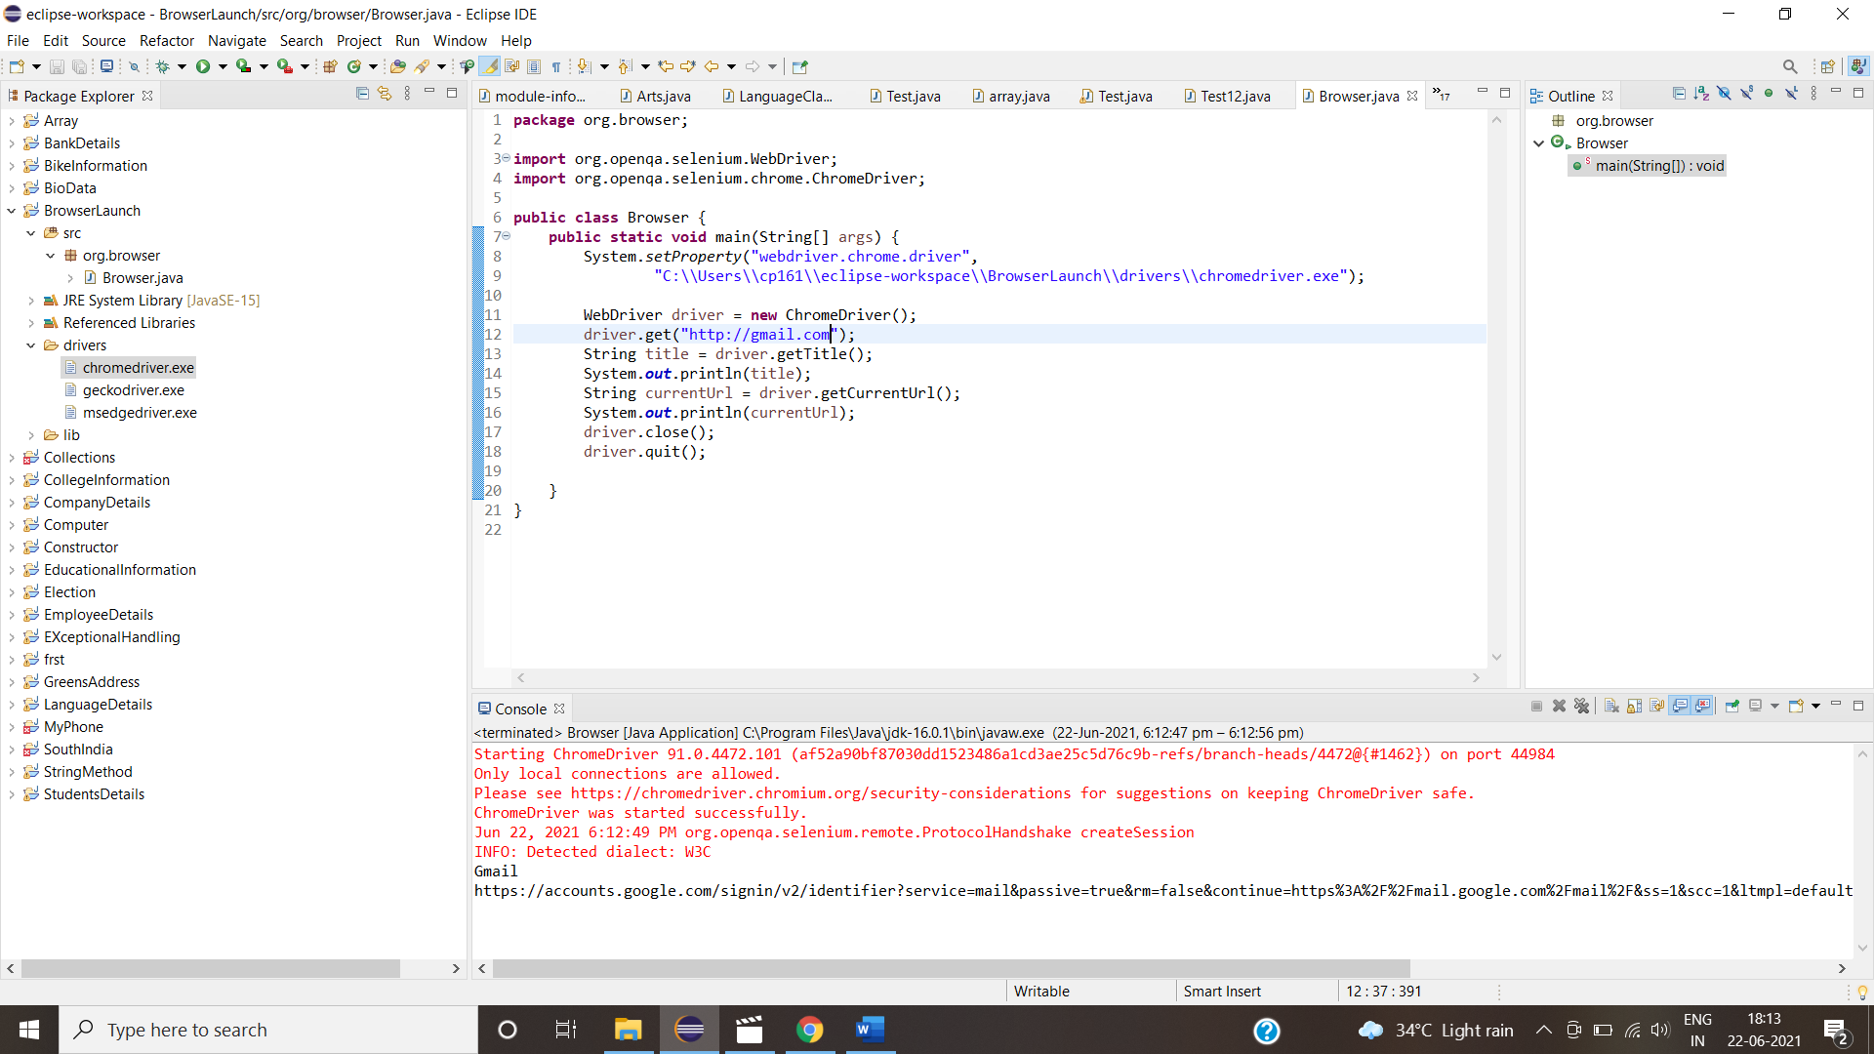

3.Flipkart - <http://www.flipkart.com/>

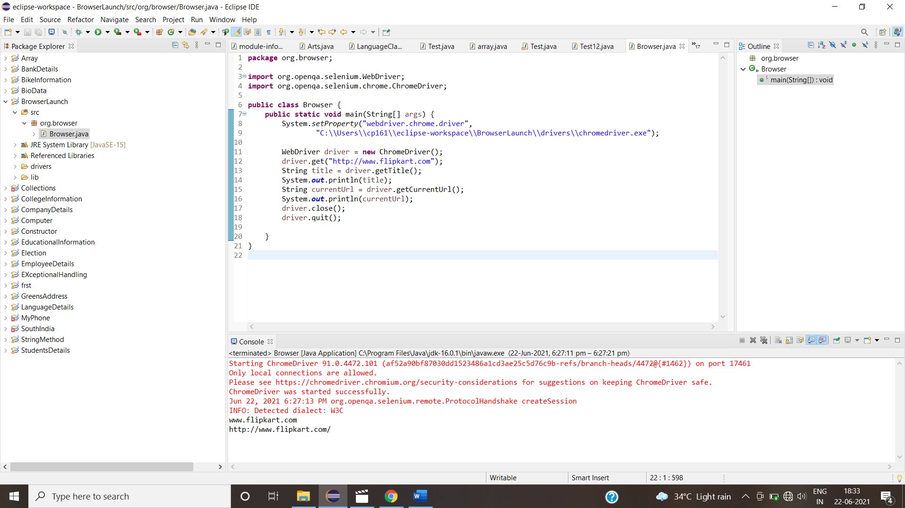

4.Greens technology-http://greenstech.in/selenium-course-content.html

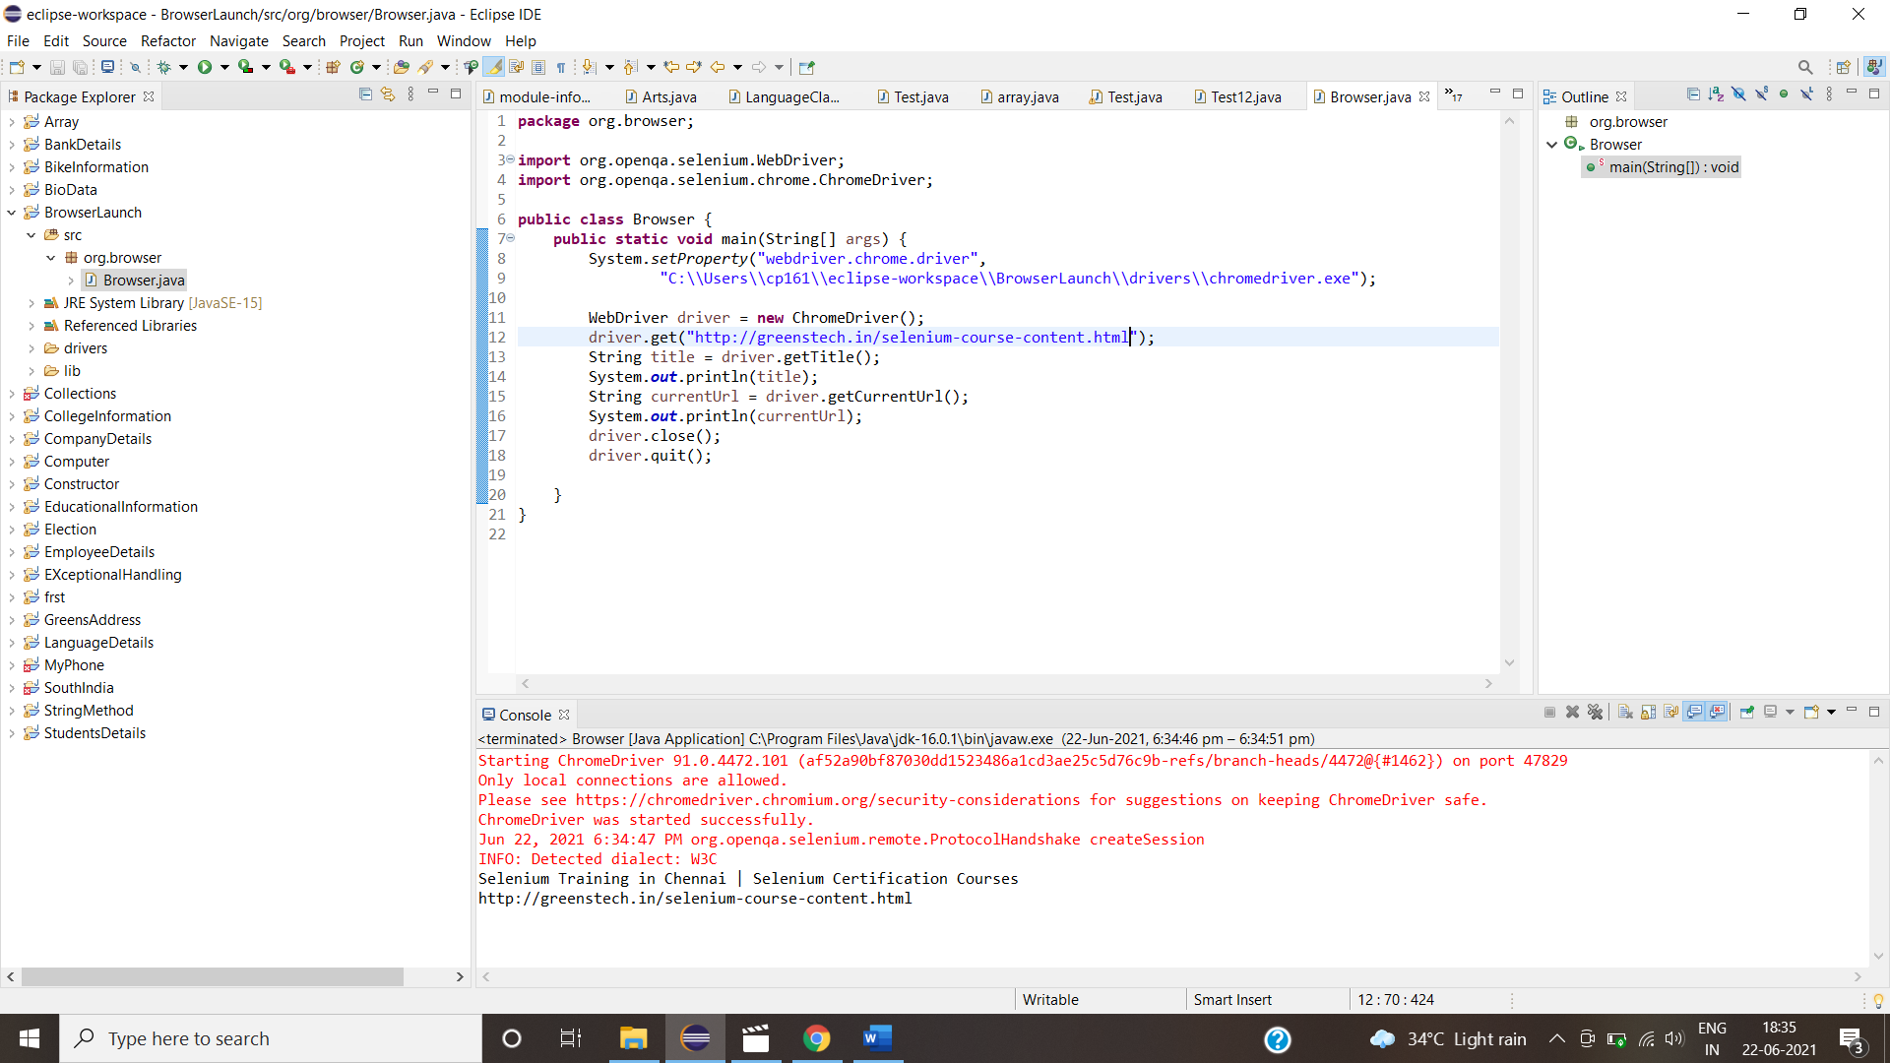

3.Launch the below URL's in IE browser:

--------------------------------------

1.Greens technologys - <http://www.greenstechnologys.com/>

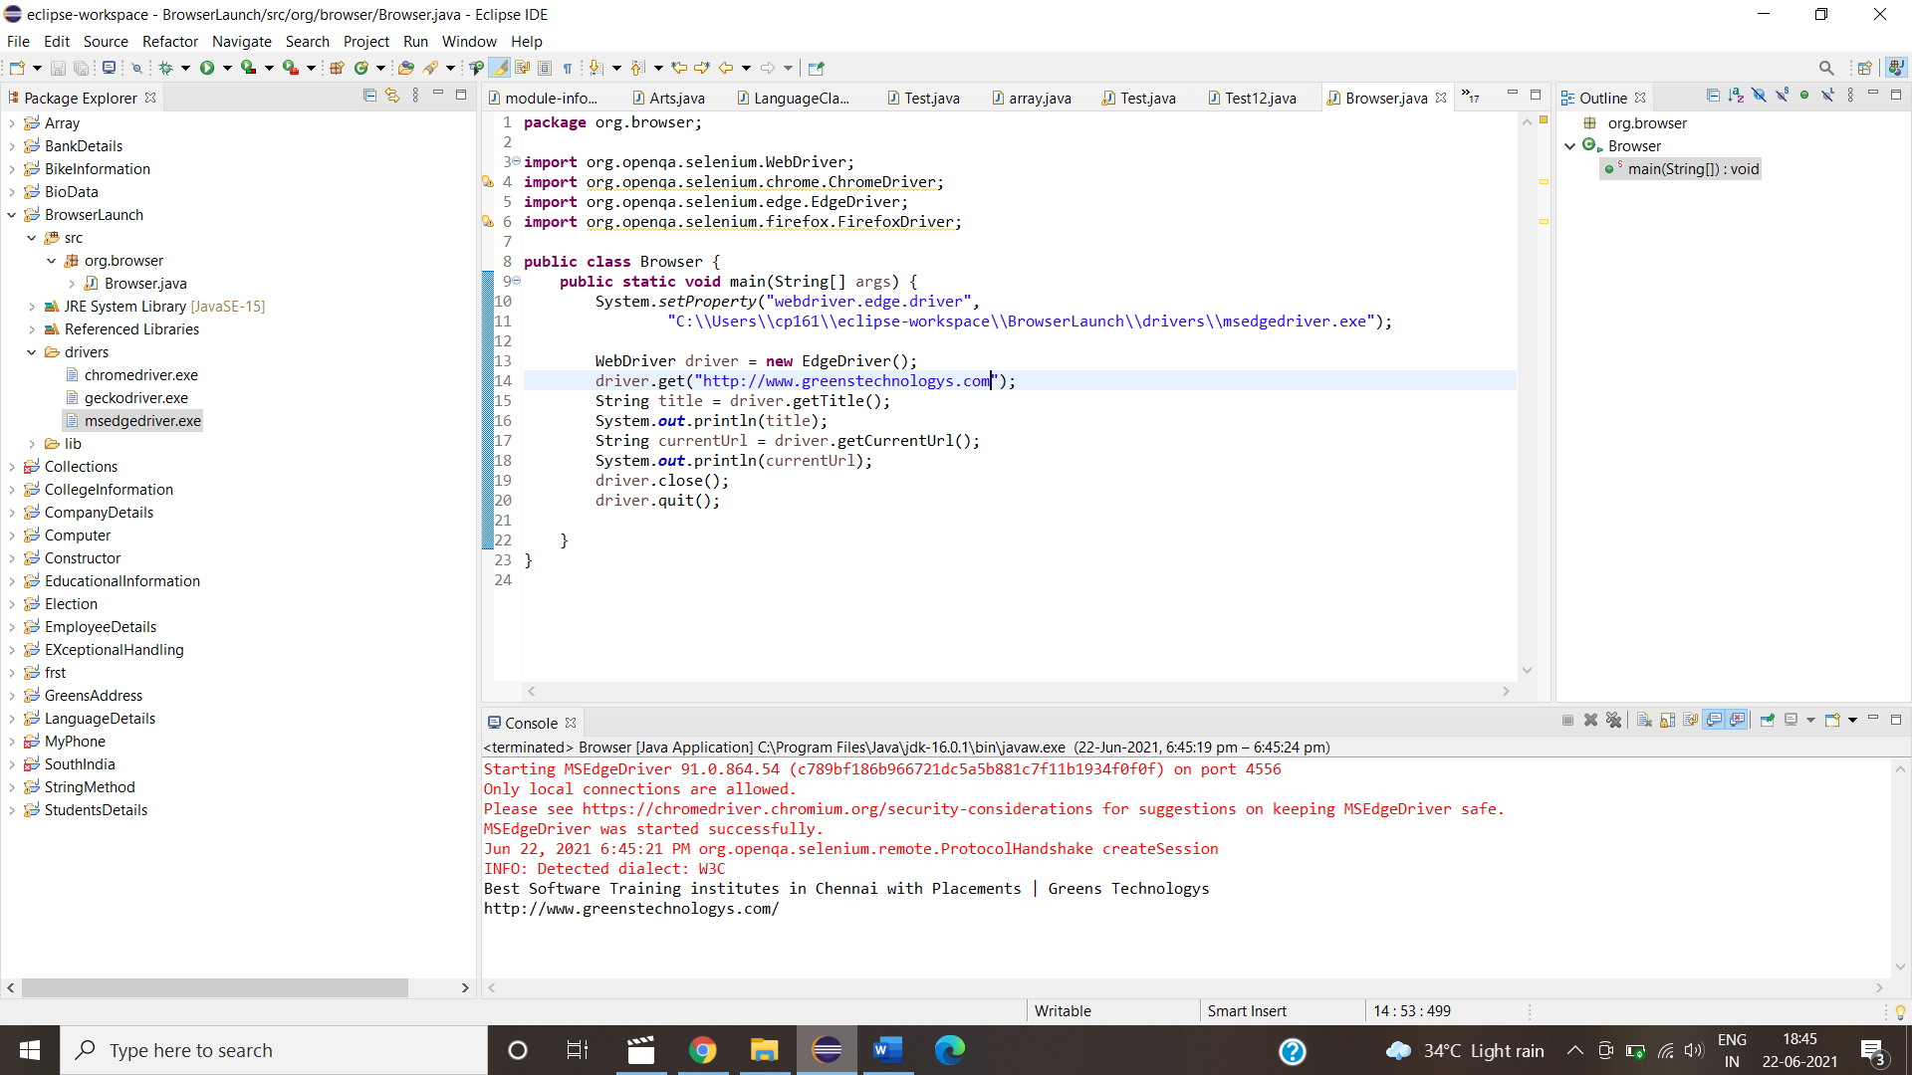

2.DemoQa Registration <http://demo.automationtesting.in/Register.html>

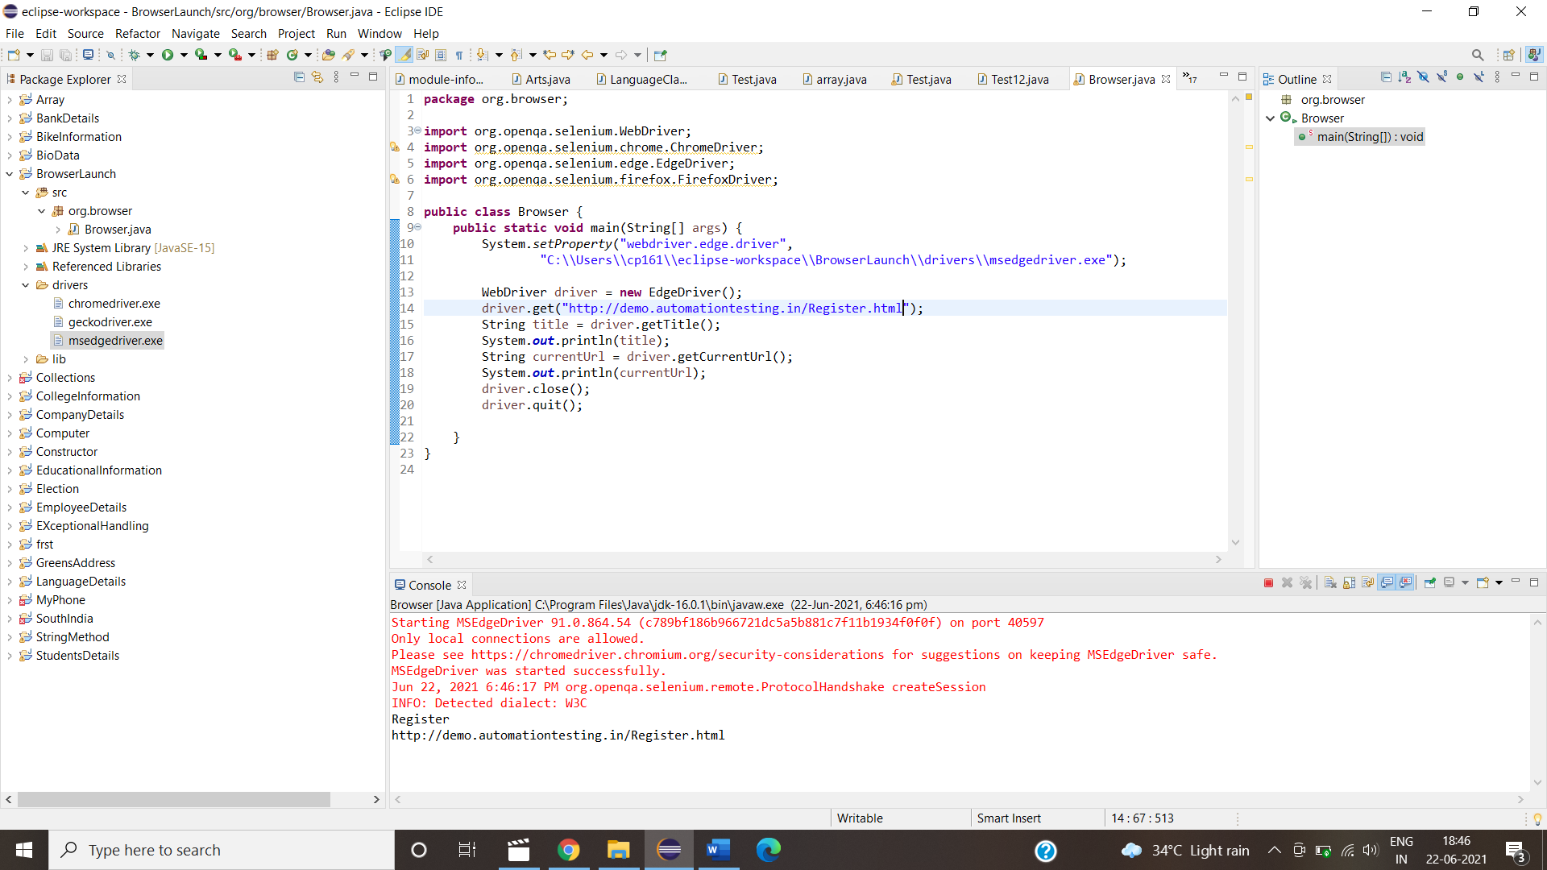

3.Greens technologys - <http://www.greenstechnologys.com/>

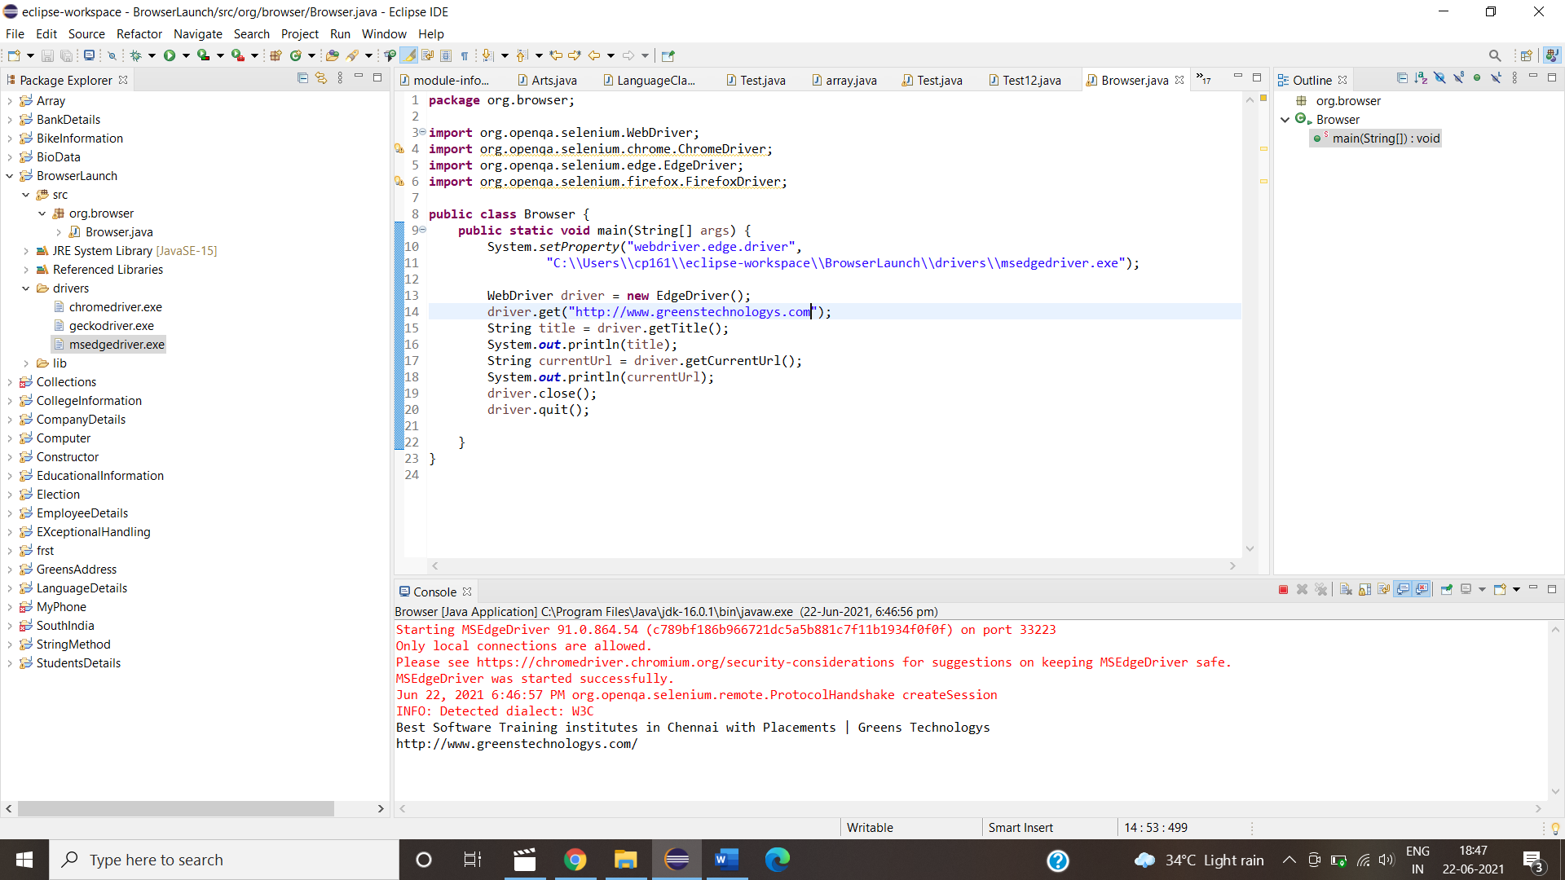

4.Greens technologys- http://greenstech.in/selenium-course-content.html 